Technical Requirements
4. Submit an updated sitemap.
I checked the sitemap I originally submitted, and since it’s what I built my website off of, nothing has changed. Here’s the original coupled with my site homepage:
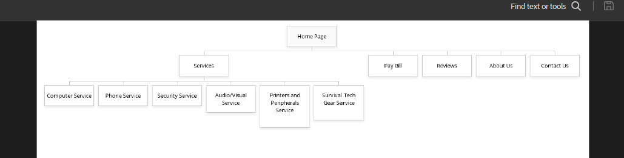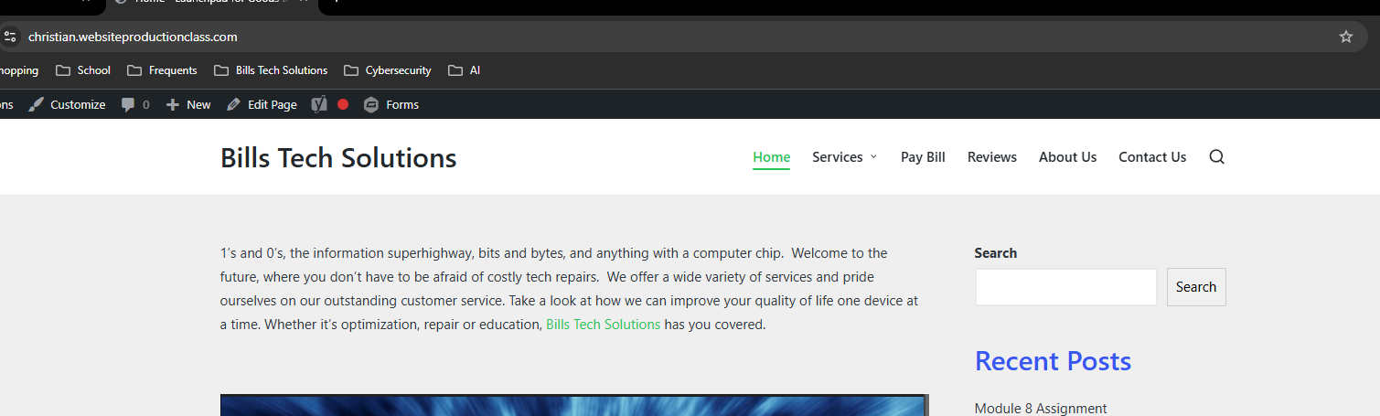

Reflection & Feedback
- Building a website with WordPress was easy! Over the course of the semester, we created a basic website which imparted foundational knowledge on website creation. We researched themes & different plugins that would be beneficial to our site. We created all the content housed on our website, and even crafted acknowledgement emails that would be sent to our clients when they used our Contact Us form. I thought the way we were guided through the site was intuitive and built upon each week’s lesson in a thoughtful manner. We covered how important pages and posts are to creating a living, breathing website that is constantly updated and upgraded. Looking at my fully functioning site now, it’s easy to see how far I’ve come since I started this course.
- Three things I learned over the course of this class were: how easy it is to get started with website creation, how robust the online tutorials are for content creation on WordPress, and how valuable it was to check out my classmates’ websites. It’s easy to be intimidated at the start. Don’t be! Even if we didn’t have Mia guiding us through the process, you can easily intuit how to get your website off the ground with some simple point-and-click action. Explore the sections of the site – they make sense, and fleshing each one out gets you that much closer to having a content complete website. If you get stuck, explore the online tutorials. I was having an issue with my pages nesting incorrectly. I was able to Google the problem and within seconds I had an answer because of how prolific WordPress is. If you need inspiration, check out your classmates’ websites! It never ceases to amaze me how smart & creative people are. You’ll see how each person handles each assignment differently, and the way they handled a given situation can provide some much-needed insight into how to best accomplish a task.
- One area I would like to learn more about is advanced SEO. It’s very hard to get visibility on your site if you’re not coming up on that first page of Google search results. So, this is a critical function, and I’d love to take a class solely based on SEO.
- The one improvement I would make to this course is for the ability to pick a different theme at the very end of the course and receive feedback from the instructor on why this theme is a good choice given the content, or a bad choice. To have a professional critique of why a theme would work, or wouldn’t, would’ve been a wonderful opportunity. The last part of the final could be, “now select a unique theme for your website, and explain why it appeals to you.” We had this as part of the module 8 assignment, but we didn’t get to implement it – just research it. That’s the only improvement I would like to see.
Project Accuracy & Completion
My Midterm Project feedback was:
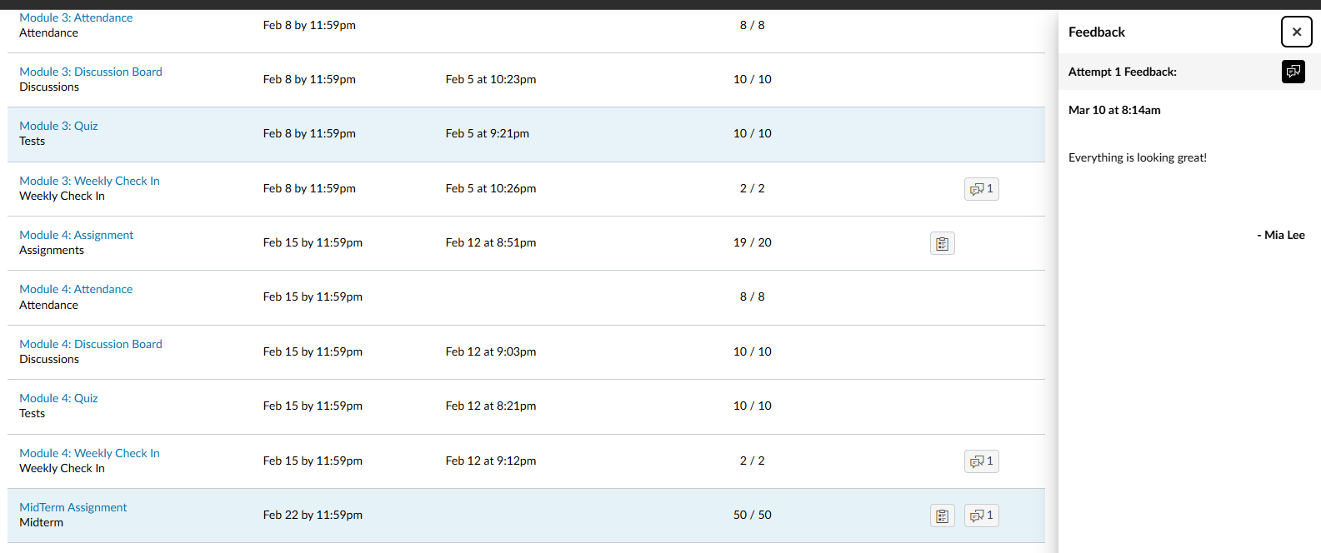
So, I took that as I’m on the right track. However, I did receive this feedback under the Module 5 assignment:
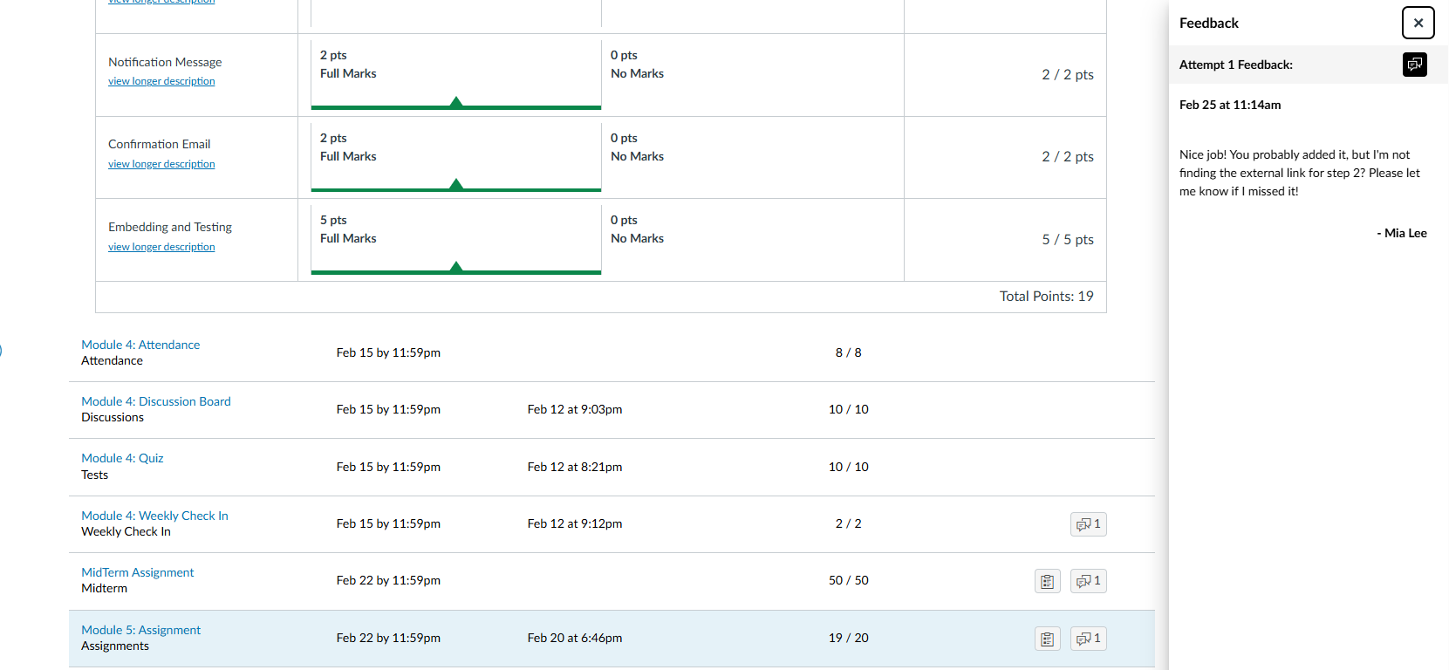
My external link blended in so much that it was unnoticeable. To correct this, I rearranged the sentence that housed the link so more attention is drawn to it. I believe it’s under Security Services, and another one is under Survival Gear. Excellent feedback!

